# **Inception ResNet v2 Architecture**

**Stem Block**

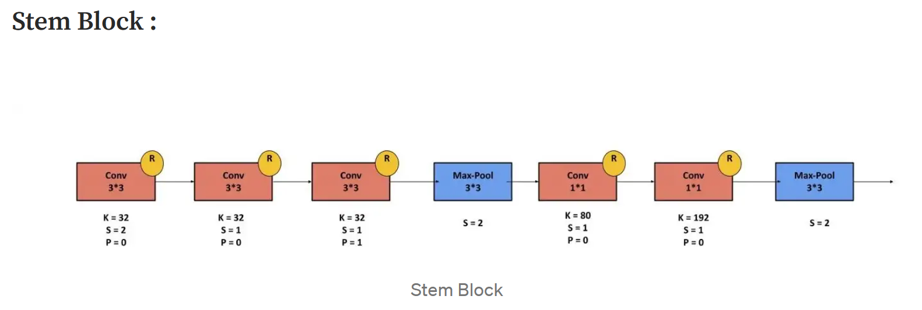

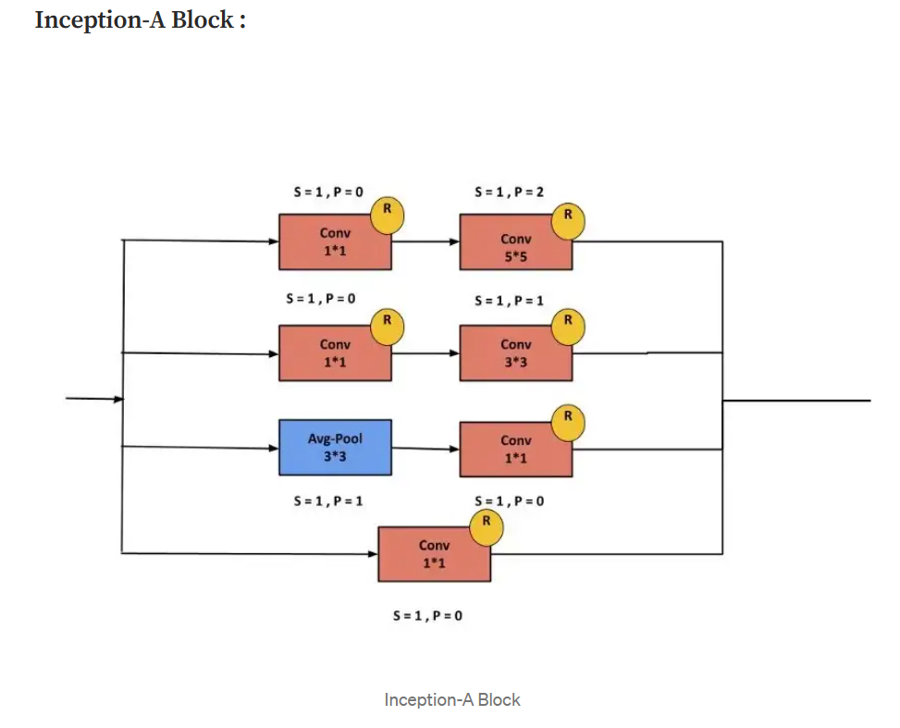**Inception A**

**Inception ResNet A**

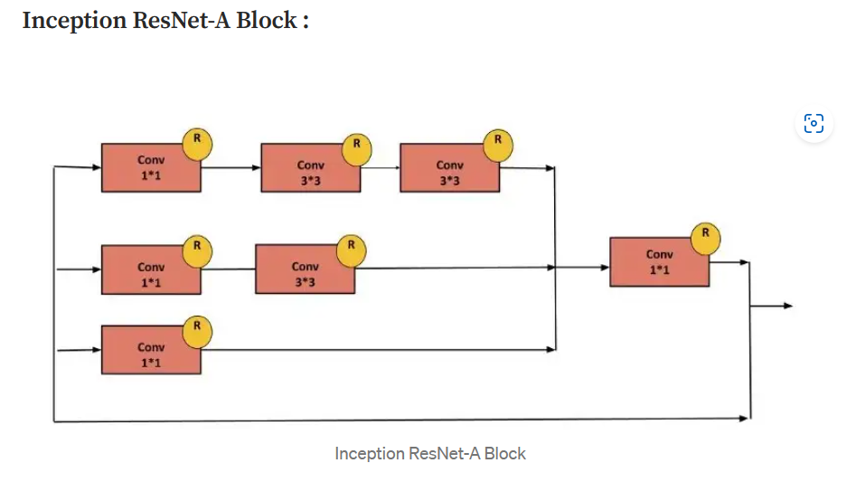

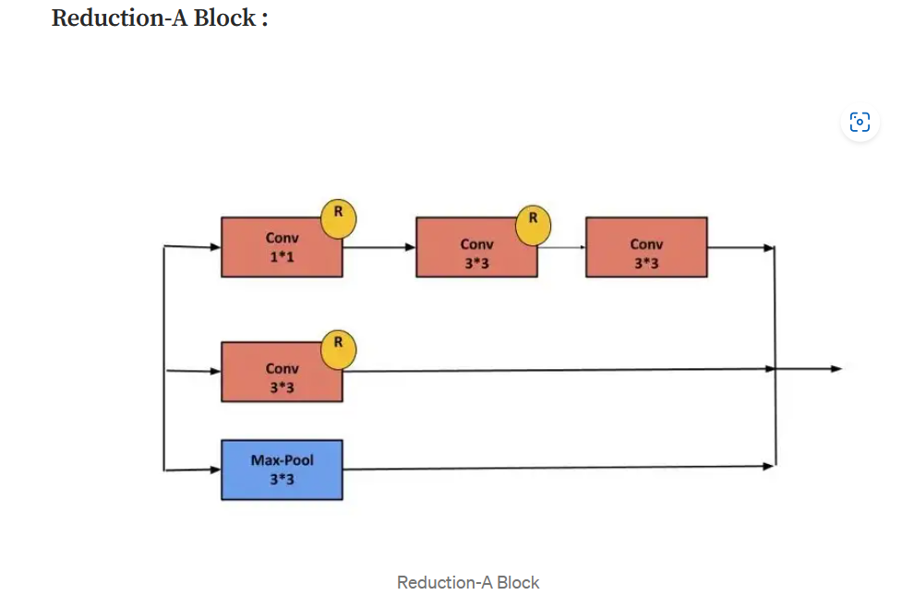**Reduction A**

**Inception ResNet B**

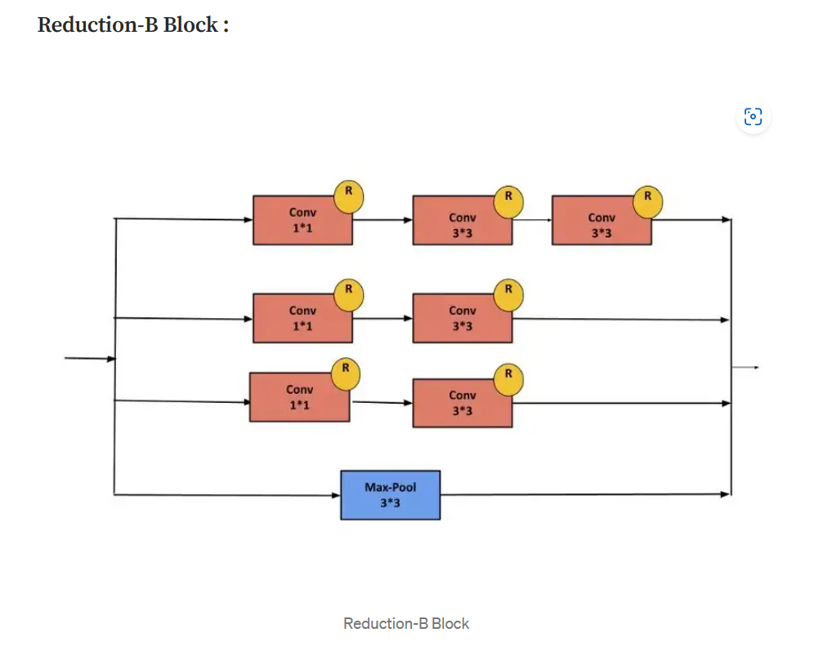**Reduction B**

**Inception ResNet C**

